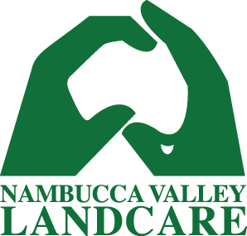

Nambucca Valley Landcare Newsletter
Summer 2016

Landcare update

Nambucca Valley Landcare's Tim Ryan wins NSW Coastal Management Award
For over 18 years, Tim Ryan has passionately put his time and energy into restoring and rehabilitating the Nambucca River as a coordinator at Nambucca Valley Landcare.
On Thursday 10 November, Professor Bruce Thom AM honoured Tim's efforts by presenting him with the Community Involvement Award at the NSW Coastal Management Awards in Coffs Harbour.
Professor Thom gave the audience a glowing overview of Tim's work, highlighting his coordination of landholders, Indigenous groups, government agencies and businesses to improve over 10km of the estuary, with flow-on benefits for the NSW mid-north coastal zone.
Tim was recognised for tirelessly persisting to secure resources and raise awareness to enhance and protect Nambucca's vitally important river

system.

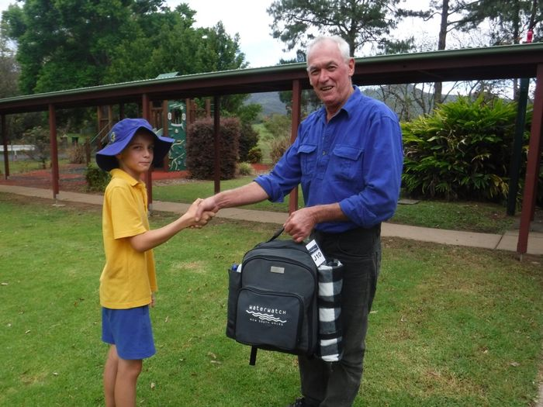

Tim Ryan presenting a young Landcarer from Medlow Public School with a Waterwatch Kit

Local Landcare Coordinator Initiative
We're very excited to announce that new funding from the NSW Government has provided Nambucca Valley Landcare with the opportunity to hire a new coordinator. The aim of the funding is to increase community engagement and support, and improve our financial sustainability, governance and reporting.

Through a selection process, the NVL committee and staff hired Logan Zingus, who started in July. Logan has a background in community development and environmental management, and has relocated from Canberra to a small property off North Arm.

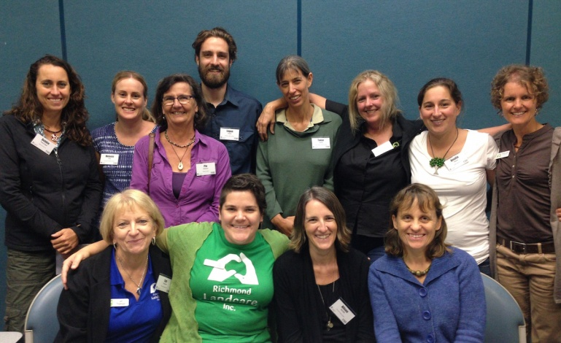
NSW North Coast Local Landcare Coordinators – NVL’s Logan Zingus is fourth from the left

Have your say: how can Nambucca Valley Landcare best support you?
Our aim at Nambucca Valley Landcare is to meet the needs of our members and community. We’d like to hear your views on how we can best support you in your natural resource management and sustainable agriculture efforts.

Attached at the bottom of this newsletter is a short survey. You can fill it out electronically and reply to this email, print it out and send it in, or stop by the office to tell us what you think.

Help control Indian Mynas
The Indian Myna bird was introduced into Australia in the 1860's and has become a major pest animal. Indian Mynas are extremely aggressive, competing with native birds for food and habitat. They are also an agricultural pest, and cause damage to crops and infrastructure.

Spring is the season when Indian Mynas are most active and destructive, and we’ve noticed a spike in their numbers around the valley. Nambucca Valley Landcare, with support from the Nambucca Shire Council, support landholders to control Indian Myna through a trapping program, using specialised traps to humanely catch and euthanise the birds.

If you’d like to borrow a trap for your house or property, we’re happy to help you. Contact the office for more information.

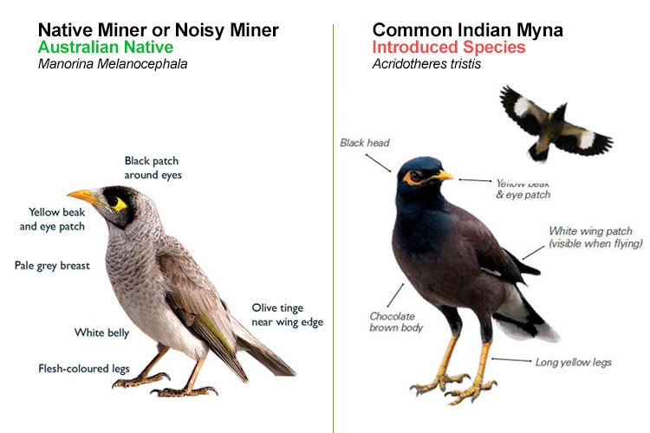
Native Miner vs Indian Myna

Our new website
Check out NVL’s new look website at: nvlandcare.org.au

If you have any natural resource related local news, photos or stories to share, let us know and we’re happy to host them online.

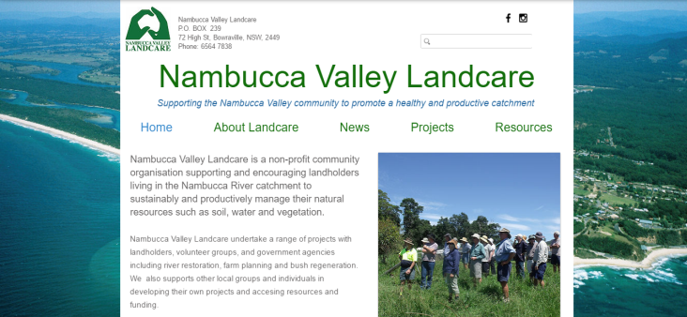
The new Nambucca Valley Landcare website

Opportunities
Recovery Grants for Disaster Affected Farmers
The Commonwealth and NSW governments have announced additional disaster funding to assist banana growers and shellfish producers who were severely affected by storms and floods in June 2016 through the Commonwealth-State Natural Disaster Relief and Recovery Arrangements (NDRRA).
The recovery grants are available to:
- eligible primary producers in the banana sector in the five local government areas (LGAs) of Ballina, Coffs Harbour, Kempsey, Nambucca and Tweed; and
- eligible primary producers in the shellfish sector in the six LGAs of Bega, Byron, Eurobodalla, Nambucca, Shoalhaven and Tweed.
To apply for a recovery grant, primary producers in the eligible local government councils can contact the NSW Rural Assistance Authority on 1800 678 593 or visit Department of Primary Industries Rural Assistance Authority website.
Norman Wettenhall Foundation Small Grants
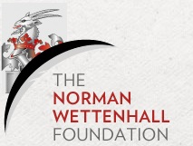
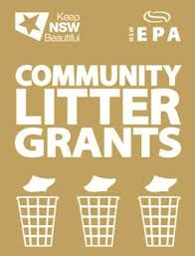
The Norman Wettenhall Foundation are offering funding to provide support for groups or individuals undertaking projects that will make a positive difference to the natural living environment, in land, sea or air, rural or urban.
This round of funding is focused on projects aimed at flora and fauna conservation, threatened mammal conservation, and landscape restoration and education.
November grants are now open for application, and the round closes when they have received enough suitable applications.
If you have a project in mind, Nambucca Valley Landcare would love to hear about it and provide advice and guidance to support your application.
For more information visit: http://nwf.org.au/grants/small-environmental-grants/
Community Litter Grants
Community Litter Grants started in 2013 to equip locals with tools and resources to implement litter solutions in their neighbourhoods.
All organisations applying for a grant must first conduct a Local Litter Check, which uses specific methodology to collect information on a litter 'hotspot' and compare it with a clean area. The comparison allows you to drill down what will be most effective in your community. Your community group will receive $500 reimbursement for completing your local litter check.
Your group is then eligible to design a litter reduction grant project and request up to $5,000 (GST inclusive).
For more info, phone 02 8594 4000.
Farming Together- Cooperatives and Collaboration Partnership Pilot
The $14.9m Farming Together Initiative is a national, two-year campaign for primary producers and processors to collaborate and claim marketplace power.
Visit the website and complete the simple self-assessment - no extensive forms to fill in.
All farmers who register receive one-on-one expert advice to discuss their opportunities and appetite to create a successful collaborative group. This could be either as a structured co-operative, as a collective bargaining entity or as a less-formal collaborative group. The most-promising groups will be offered assistance for product research and development. Areas that are covered include advice on marketing, capital-raising, packaging, logistics and exporting as well as non-ongoing consultancy appointments.
For more information, phone Nick or Andrew on 1800 00 55 55, or email: info@farmingtogether.com.au
Current Projects
River restoration continues: Wilsons Road Bank Stablisation Projects
Nambucca Valley Landcare is continuing work on repairing our beautiful river by leading two projects on adjacent properties in Congarini North. The projects aim to stabilise 660m of river banks by creating rock fillets to reduce the impact of wake and allow mangroves to establish, preventing stock access through fencing, and planting native species with root systems that help stabilise the foreshore. The overall objective of the project is to improve water quality, increase fish habitat and restore the health of the river for generations to come.
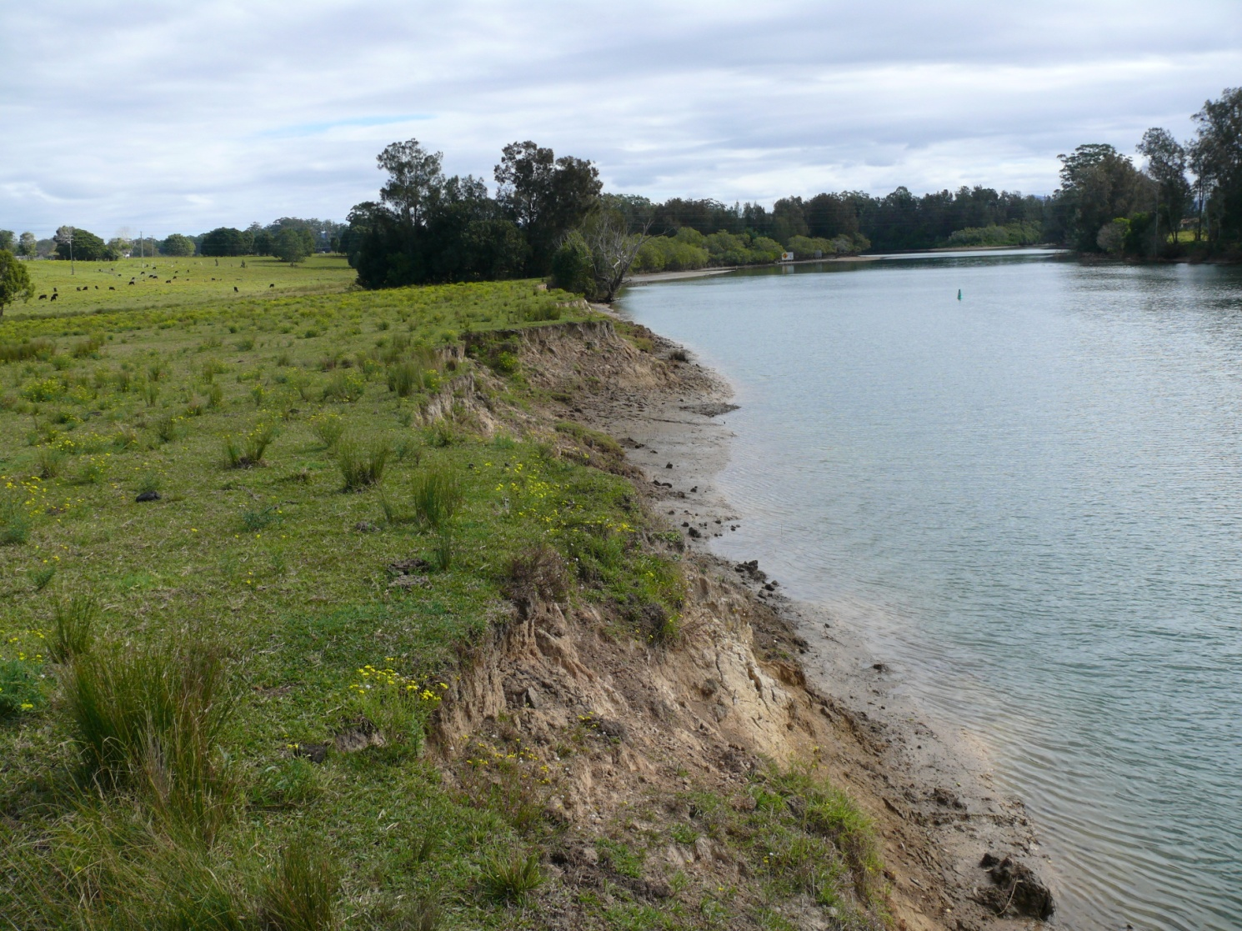
Section of degraded bank along Wilsons Road before restoration work

Yarrahapinni to Killikrankie Bush Connect
Macleay Landcare, North Coast Local Land Services, Nambucca Shire Council, NSW Environmental Trust and NSW National Park and Wildlife Service have partnered with Nambucca Valley Landcare for the Yarrahappini to Killiekrankie (Y2K) Bush Connect project.

The Y2K project is aimed at working with landholders and public land managers to improve the condition of the environment within the Great Eastern Ranges corridor, including by linking natural bush areas. The Environmental Trust has engaged NVL to manage the Nambucca Valley component of the project from 2016 to 2021.

The target for the Nambucca Valley is an area around Taylors Arm and Yarranbella, selected by the Environmental Trust as a priority for habitat connectivity. NVL are now working with seven landholders to create a habitat corridor through their properties to connect bush in the Ngambaa Nature Reserve to the south, with the Dunggir and New England National Parks to the north.

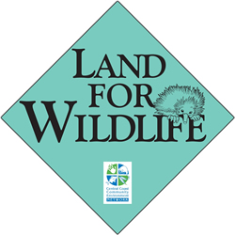
Land for Wildlife 2016
Our regional Land for Wildlife coordinator Joy van Son has made a tremendous effort in signing up a further 12 landholders to the Land for Wildlife program. We now have 27 landholders in the Nambucca Valley who have committed to managing part of their land for habitat conservation. The group also has a social element, and gathers at local and regional events to share stories about their ongoing environmental activities, success and learnings, and some tasty food, too.
The 2016 Land for Wildlife gathering was held at Sarah and Peter’s place in Girralong, who have a spectacular remnant rainforest connected to other habitat types. Sarah and Peter have also engaged in extensive bush regeneration around their property, removing large lantana infestations and replanting with native rainforest species.
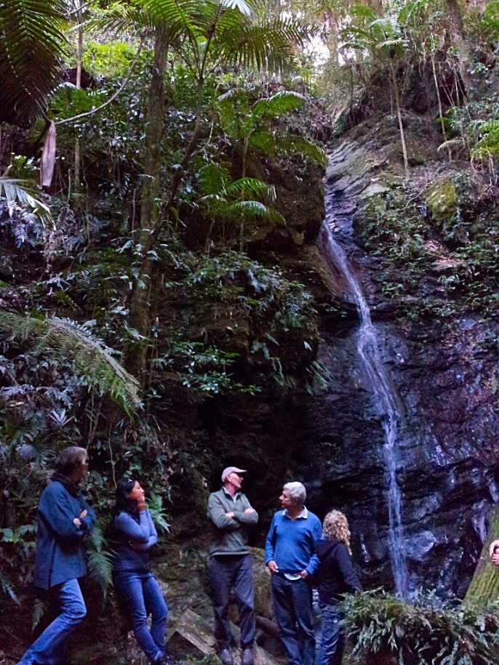
If you’re interested in registering your property in the Land for Wildlife Program, or you’d like some more information, contact Joy van Son on 65647497 or joyvanson@skymesh.com.au.

Recent projects
NVL's river work makes the news
Nambucca Valley Landcare's river restoration work has been featured in media outlets across the mid-north coast, including national coverage on the ABC.
The articles highlighted NVL's new techniques used in two bank stabilisation projects funded by NSW Fisheries under fish habitat protection grants. In addition to using rocks to create filets and revetment, the project team sourced leftover tree stumps from the pacific highway expansion as construction material.
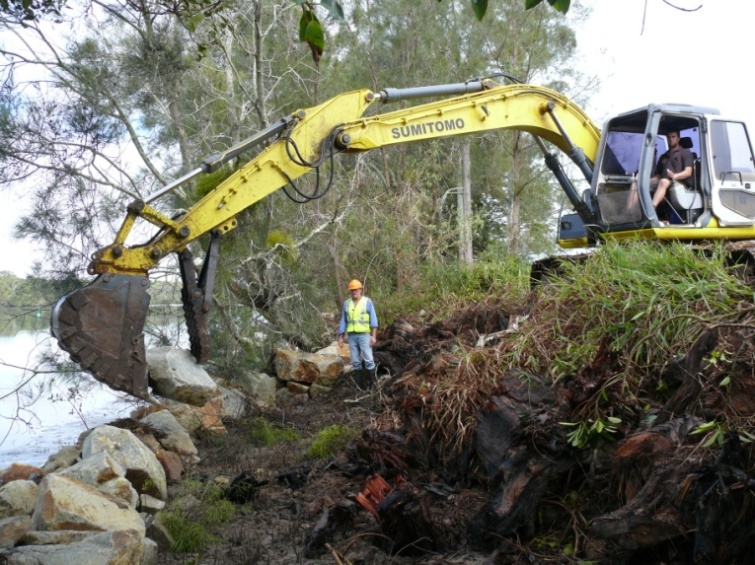
NVL's Tim Ryan and contractor Allan Bransgrove creating rock fillets along the lower Nambucca estuary, with tree stumps in the foreground

Animal Health
From our local vet
Nexgard Chewable – As we approach tick season, it’s worth considering preventative treatments for your dog. Nexgard is chewable treatment effective against ticks and fleas for three months. It’s a great product for working dogs that get wet and those who like to swim.

Disease Alert for Dogs in the Nambucca Valley - Parvovirus outbreak
Over the past few weeks, numerous unvaccinated puppies have been brought to the Macksville and Nambucca Heads Veterinary Clinics with severe gastroenteritis (vomiting and diarrhoea). It is highly likely that Parvovirus is the cause of this outbreak.

Parvovirus or parvo as it is sometimes called, is a virus that attacks the gastrointestinal tract and cardiovascular systems of dogs. Parvovirus is spread by oral or nasal contact with contaminated faeces, a contaminated environment or contaminated objects.

Parvovirus is highly contagious and resistant to the effects of heat, detergents and alcohol so it can remain in the environment for up to a year after an infected dog has been there. It is possible that you may bring the virus home on your shoes, clothes or car, so even pups that never leave your home can be infected. Dogs that become infected with the virus and show clinical signs will usually become ill within 7-10 days.
Clinical signs of parvovirus include loss of appetite, severe vomiting, diarrhoea (this may contain blood), dehydration, weakness. It is important to note that many dogs may NOT show every clinical sign. Parvovirus can affect dogs of all ages, but is most common in dogs less than one year of age.

Without treatment, approximately 95% of dogs suffering from parvovirus will die. With treatment, survival can range from 65-95%.

Treatment of infected patients is very intensive and costly. The dogs need to be kept in isolation wards and monitored closely.

Parvovirus is a prime example of where prevention is better than cure. Prevention is simple, safe and very effective. Vaccination provides excellent protection to your dogs and all pups should receive their first vaccination at 6 – 8 weeks of age followed by 2 more vaccinations at monthly intervals. Immunity is then maintained by vaccinating annually. Older dogs that have never been vaccinated can be protected with 2 vaccinations a month apart.
Please contact Macksville Veterinary Clinic for further information or advice:

Macksville Veterinary Clinic
6568 125

Nambucca Valley Landcare member survey

1. What is the size of your property?
Less than 1 hectare (2.5 acres)
1-5 hectares (2.5 - 12 acres)
5-20 hectares (12 - 49 acres)
20-50 hectares (49 - 123 acres)
>50 hectares (>123 acres)

2. What is your land used for? (You can choose more than one.)
Residential
Beef cattle
Dairy cattle
Nut production
Other horticulture
Vegetable production
Forestry
Habitat conservation
Other (please specify)

3. What land management topics are you most interested in? (You can choose more than one.)
Revegetation
Pest animal control
Weed control
Repairing land degradation (e.g. erosion, salinity)
Aquaculture and sustainable fisheries
Sustainable food production
Community awareness
Environmental and sustainable agriculture education in schools
Recovery from natural disasters –(e.g. floods)
Climate change adaptation
Understanding regulation
Sustainable forestry
Other (please specify)

4. What activities have you engaged in? (You can choose more than one.)
Revegetation
Pest animal control
Weed control
Repairing land degradation (e.g. erosion, salinity)
Aquaculture and sustainable fisheries
Sustainable food production
Community awareness
Environmental and sustainable agriculture education in schools
Recovery from natural disasters (e.g. floods)
Climate change adaptation
Understanding regulation
Sustainable forestry
Other (please specify)

5. What information would help you manage your land or collaborate to improve public land? (You can choose more than one.)
Plant and animal identification
Bush regeneration skills
Managing land degradation (e.g. erosion and salinity)
Soil health
Sustainable food production
Pest animal management
Weed control
Understanding regulation
Water management
Sustainable forestry
Property planning and site assessment
Farm productivity information and events
Other (please specify)

6. What is the best way to communicate with you? (You can choose more than one.)
Shopfront
Email
Post
Website
Workshops/field days
Social media (e.g. Facebook)
Other (please specify)

7. What is the biggest challenge you face in managing your land sustainably or helping improve the health of our valley? (You can choose more than one.)
Lack of time
Lack of available funds
Lack of available resources (e.g. local tubestock)
It's difficult to plan or prioritise
I'm not sure what my rights are under the law
I don't know where or how to volunteer
I don't know where to begin

8. Do you have any other comments, questions, or concerns?

